**SENIOR SECONDARY**

**M.E.S CENTRAL SCHOOL, TIRUR**



**COMPUTER SCIENCE**

**LABORATORY RECORD**

**GRADE XII 2023-24**

**SENIOR SECONDARY**

**M.E.S CENTRAL SCHOOL, TIRUR**



Certified to be the bona fide record of work done by **___AMAN_K__** (Reg. No____________) of class XII for SSCE-Practical Examination in Computer Science (083), during the year 2023-2024

RENU G.

Teacher-in-charge

Date of Exam:

Examiners:

1.

2.

Principal

**INDEX**

|  |  |  |  |
| --- | --- | --- | --- |
| SI No. | Name of Assignment | Date | Page No. |
| **PYTHON PROGRAMS** | | | |
| 1 | MENU DRIVEN PROGRAM TO CALCULATE AREA OF RECTANGLE,SQUARE,TRIANGLE,CIRCLE | 06.06.2022 |  |
| 2 | DICTIONARY -INFORMATION OF AN EMPLOYEE(NAME,DESIGNATION,SALARY) | 07.06.2022 |  |
| 3 | FACTORIAL OF A NUMBER USING FUNCTION | 07.06.2022 |  |
| 4 | TO FIND LARGEST ELEMENT IN A LIST USING FUNCTION | 09.06.2022 |  |
| 5 | CHECK WHETHER A STRING IS PALINDROME OR NOT USING FUNCTION | 09.06.2022 |  |
| 6 | TO FIND SUM OF ELEMENTS IN A LIST USING FUNCTION | 16.06.2022 |  |
| 7 | TO PRINT N FIBONACCI SERIES USING FUNCTION | 16.06.2022 |  |
| 8 | TO ADD THREE NUMBERS USING FUNCTION (USE DEFAULT ARGUMENTS) | 16.06.2022 |  |
| 9 | TO PERFORM LINEAR SEARCH | 23.06.2022 |  |
| 10 | TO FIND LARGEST OF TWO NUMBERS USING FUNCTION | 23.06.2022 |  |
| 11 | TO GENERATE RANDOM NUMBERS between 1 and 6 (simulates a dice). | 23.06.2022 |  |
| 12 | TEXT FILES – WRITING AND READING TO AND FROM A TEXT FILE | 30.06.2022 |  |
| 13 | TEXT FILES – NUMBER OF LINES STARTING WITH ‘A’ | 30.06.2022 |  |
| 14 | TEXT FILES – DISPLAY WORDS WHICH HAS LESS THAN FOUR CHARACTERS | 07.07.2022 |  |
| 15 | BINARY FILE – LOAD AND DUMP BOOK DETAILS | 14.07.2022 |  |
| 16 | BINARY FILE – SEARCH STUDENT DETAILS IF ROLLNUMBER IS GIVEN | 21.07.2022 |  |
| 17 | CSV FILE – READING DATA FROM A CSV FILE | 04.08.2022 |  |
| 18 | CSV FILE – WRITING DATA TO A CSV FILE | 04.08.2022 |  |
| 19 | IMPLEMENT STACK AS A LIST | 29.09.2022 |  |
|  | **SQL** |  |  |
| 20 | SQL QUERIES RELATION TEACHER | 6.10.2022 |  |
| 21 | SQL QUERIES RELATION STOCK AND DEALERS | 13.10.2022 |  |
| 22 | SQL QUERIES RELATION EMPLOYEE AND SALGRADE | 20.10.2022 |  |
| 23 | PYTHON -MYSQL CONNECTIVITY PROGRAMS CREATE & INSERT RECORDS INTO TABLE | 27.10.2022 |  |
| 24 | PYTHON -MYSQL CONNECTIVITY PROGRAMS - SEARCH A RECORD | 3.10.2022 |  |
| 25 | PYTHON -MYSQL CONNECTIVITY PROGRAMS - UPDATE A RECORD | 10.11.2022 |  |
|  | | | |

***PROGRAMS IN***

***PYTHON***

**Program 1**

MENU DRIVEN PROGRAM IMPLEMENTING AREA OF SHAPES

**Coding:**

# MENU DRIVEN PROGRAM IMPLEMENTING AREA OF SHAPES

**while True:**

**print("1.Area of circle \n2.Area of rectangle \n3.Area of triangle \n4.Area of Square ")**

**m=int(input("Enter your choice"))**

**if m==1:**

**print("You chose to find area of circle")**

**n1=int(input("Enter Radius:"))**

**ac=3.14*(n1**2)**

**print("Area=", ac)**

**elif m==2:**

**print("You chose to find area of rectangle")**

**n3=int(input("Enter length:"))**

**n4=int(input("Enter breadth:"))**

**ar=n3*n4**

**print("Area=",ar)**

**elif m==3:**

**print("You chose to find area of triangle")**

**n5=int(input("Enter Length:"))**

**n6=int(input("Enter height:"))**

**at=0.5*n5*n6**

**print("Area=", at)**

**elif m==4:**

**print("You chose to find area of square")**

**n7=int(input("Enter length:"))**

**a=n7**2**

**print("Area=", a)**

**else:**

**print("Invalid operator")**

**c=input("Do you want to continue?, Yes or no?")**

**if c=="yes":**

**pass**

**else:**

**break**

**OUTPUT SCREEN**

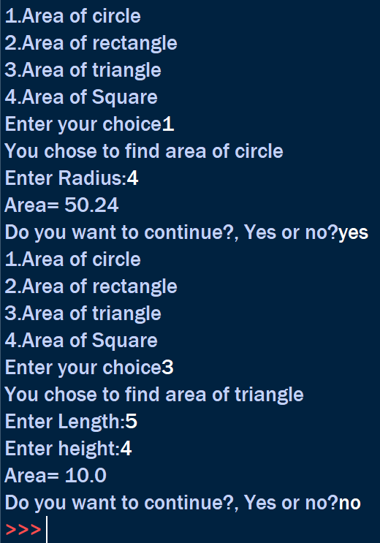

**Program 2**

****DICTIONARY -INFORMATION OF AN EMPLOYEE(NAME,DESIGNATION,SALARY)

**Coding:**

# DICTIONARY -INFORMATION OF AN EMPLOYEE(NAME,DESIGNATION,SALARY)

**emp = dict()**

**n = int(input("Enter number of entries:"))**

**for i in range(n):**

**name = input("Enter EMPLOYEE name:")**

**slr = float(input("Enter EMPLOYEE salary:"))**

**Dsn = input("Enter EMPLOYEE Designation:")**

**emp[name] = (slr, Dsn)**

**l = emp.keys()**

**print("\nName\t\t\tDesignation\t\t\tSalary")**

**for i in l:**

**print(i,"\t\t\t",emp[i][1],"\t\t\t",emp[i][0])**

**OUTPUT SCREEN**

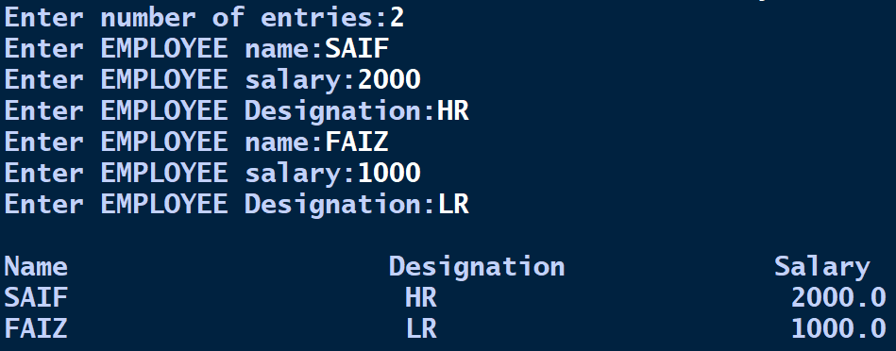

**Program 3**

FACTORIAL OF A NUMBER USING FUNCTION

**Coding:**

# FACTORIAL OF A NUMBER USING FUNCTION

**def fact(num):**

**num=num+1**

**fac=1**

**for i in range(1,num):**

**fac=fac*i**

**print(fac)**

**i = int(input("Enter number to find factorial:"))**

**fact(i)**

**OUTPUT SCREEN**

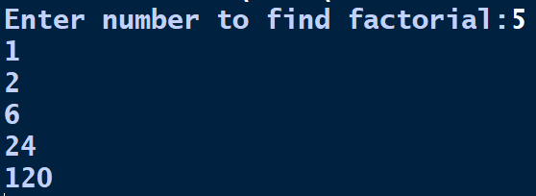

**Program 4**

TO FIND LARGEST ELEMENT IN A LIST USING FUNCTION

**Coding:**

# TO FIND LARGEST ELEMENT IN A LIST USING FUNCTION

**def inputlist():**

**a=list()**

**l = int(input("LIMIT:"))**

**for i in range(l):**

**item = int(input("ENTER ITEM TO ADD TO LIST:"))**

**a.append(item)**

**return a**

**def maxOfList(l):**

**max = l[0]**

**for i in range(len(l)):**

**if l[i]>max:**

**max = l[i]**

**print("largest element in list is :",max)**

**maxOfList(inputlist())**

**OUTPUT SCREEN**

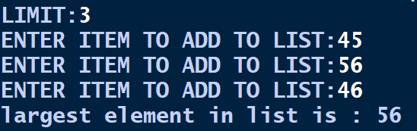

**Program 5**

CHECK WHETHER A STRING IS PALINDROME OR NOT USING FUNCTION

**Coding:**

# CHECK WHETHER A STRING IS PALINDROME OR NOT USING FUNCTION

**def pali(word):**

**w = word.upper()**

**if w == w[::-1]:**

**print(word,"is a palindrome")**

**else:**

**print(word,"is not palindrome")**

**inp = input("Enter a word to check if palindrome:")**

**pali(inp)**

**OUTPUT SCREEN**



**Program 6**

TO FIND SUM OF ELEMENTS IN A LIST USING FUNCTION

**Coding:**

# TO FIND SUM OF ELEMENTS IN A LIST USING FUNCTION

**def sum(l):**

**s = 0**

**for i in l:**

**s += i**

**return s**

**ls = list()**

**n = int(input("Enter Limit:"))**

**for i in range(n):**

**item = int(input("Enter Number:"))**

**ls.append(item)**

**print("sum of elements:",sum(ls))**

**OUTPUT SCREEN**

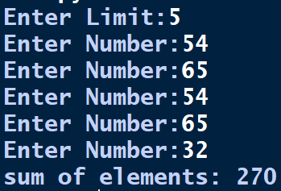

**Program 7**

TO PRINT N FIBONACCI SERIES USING FUNCTION

**Coding:**

# TO PRINT N FIBONACCI SERIES USING FUNCTION

**def fibo(n):**

**n1,n2,n3,i=0,1,0,0**

**print("Fibonacci series")**

**while i<n:**

**print(n1)**

**sum=n1+n2**

**n1=n2**

**n2=sum**

**i += 1**

**n=int(input("enter required number of terms"))**

**fibo(n)**

**OUTPUT SCREEN**

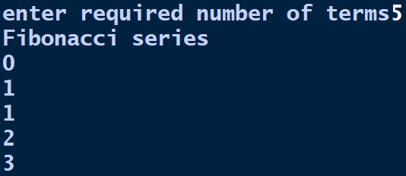

**Program 8**

***MYSQL***

Teachers

Stock & Dealers

Employee Salgrade

***PYTHON***

***MYSQL***

***CONNECTIVITY***

***PROGRAMS***

**Program 21**

PYTHON -MYSQL CONNECTIVITY PROGRAMS CREATE & INSERT RECORDS INTO TABLE

**Coding:**

# PYTHON -MYSQL CONNECTIVITY PROGRAMS CREATE & INSERT RECORDS INTO TABLE

**OUTPUT SCREEN**